LEMP project(nginx.mysql,php)

1. Create ec2 instance
2. ssh to instance

$ ssh -i key ubuntu@ip

Key permission ------🡪 400

1. update package manager

$ sudo apt update

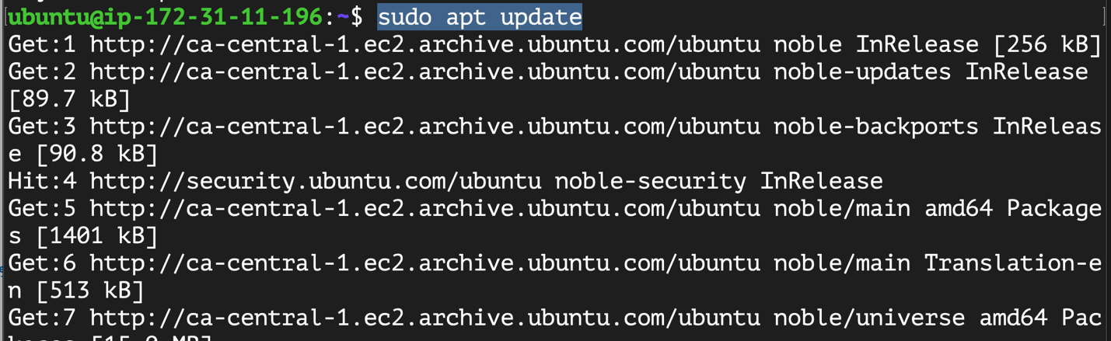

1. Install nginx

$ sudo apt install nginx

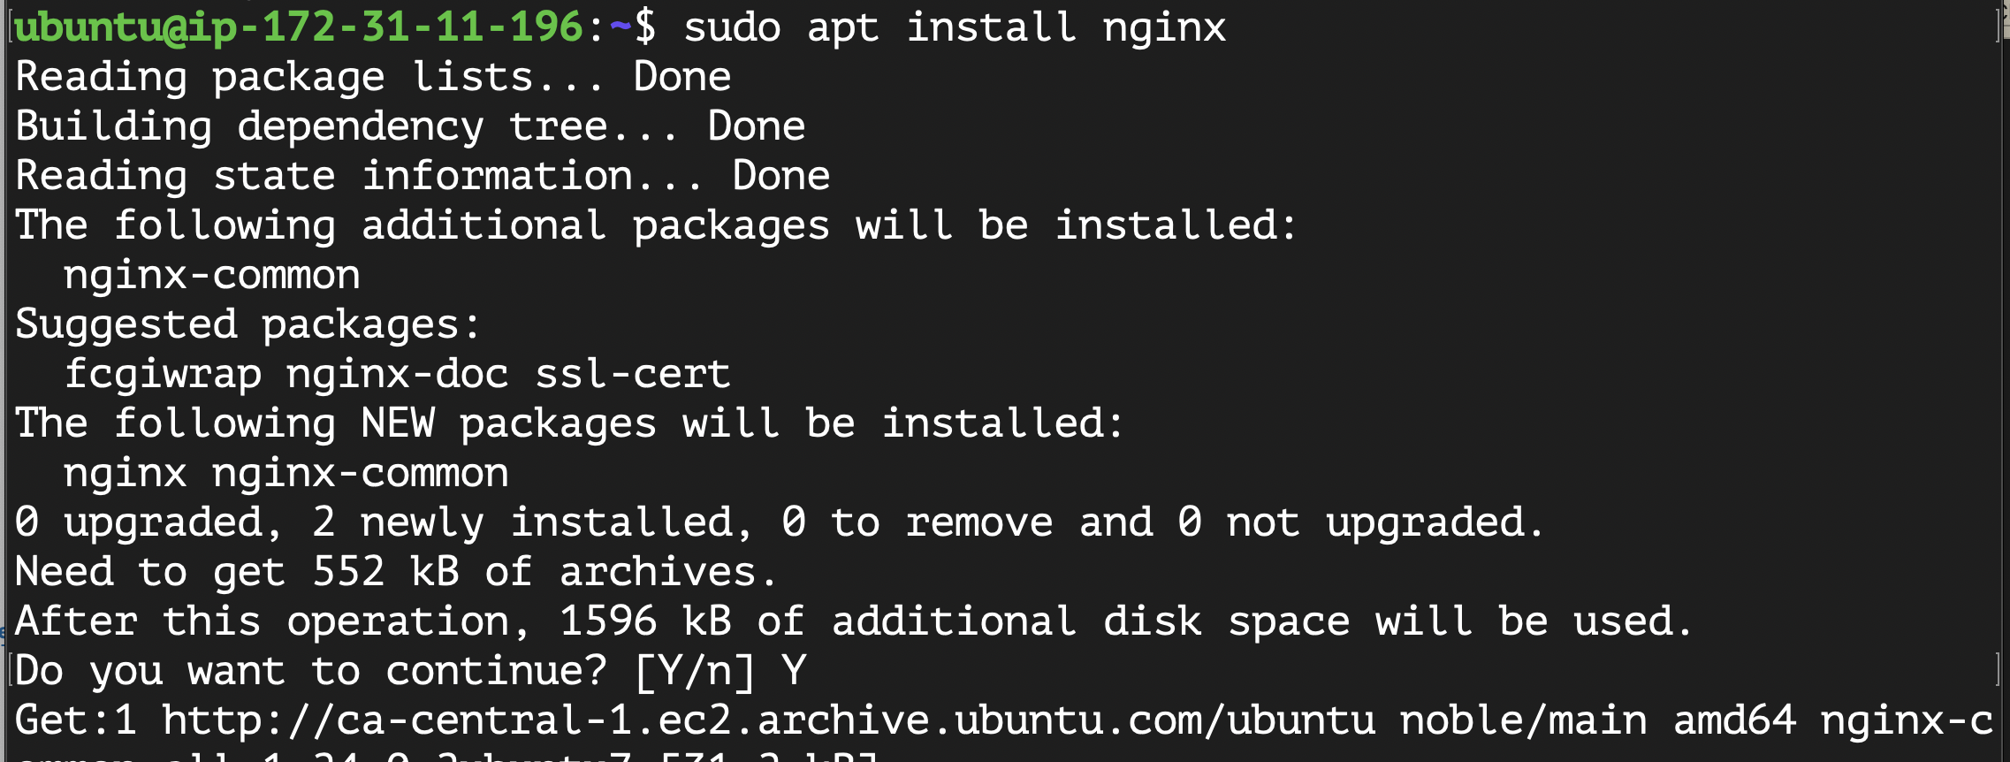

1. Ensure that nginx is up and running

$ sudo systemctl status nginx

Access nginx --------🡪

1. Install mysql

$ sudo apt install mysql-server

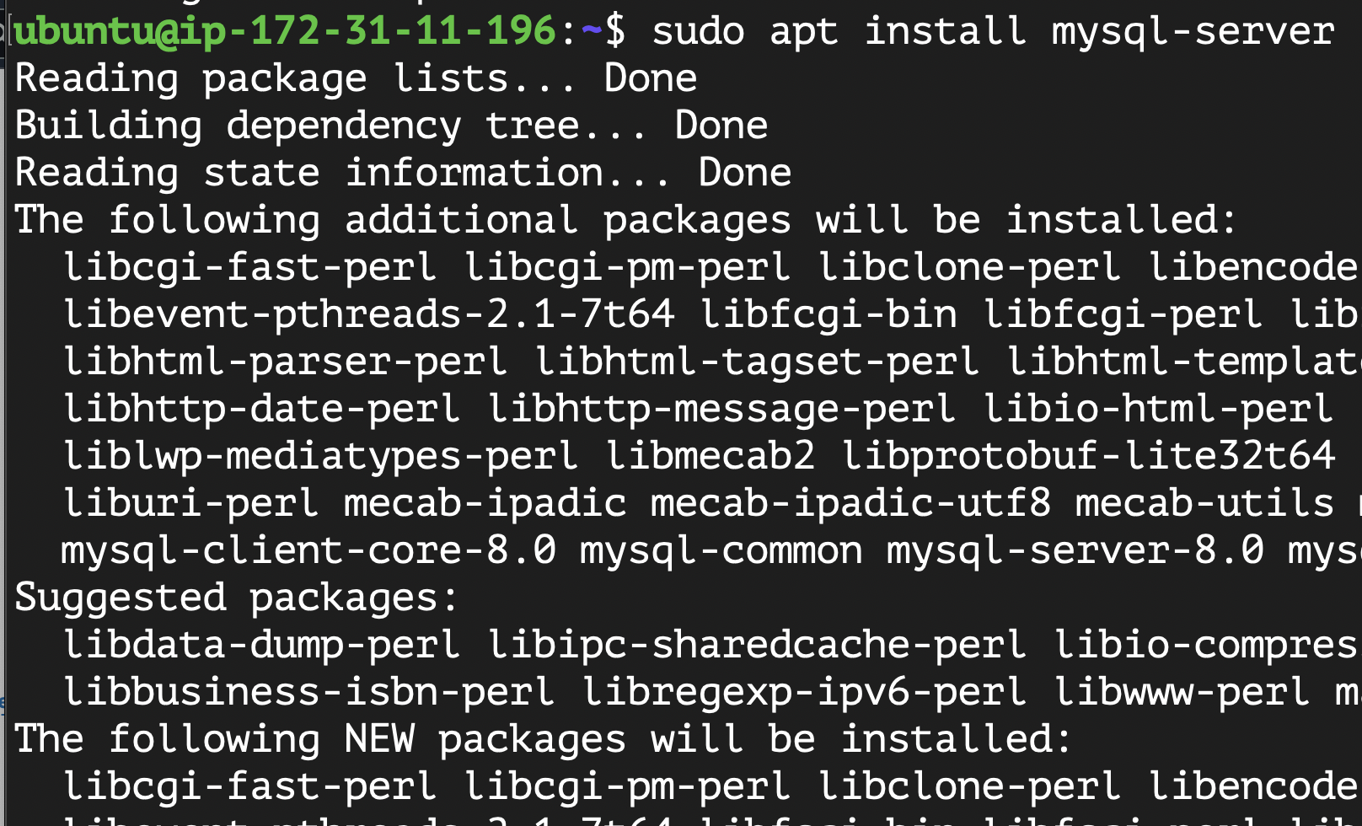

1. Install php-fpm and php-mysql

$ sudo apt install php-fpm php-mysql

1. How to change password for root user on mysql
2. First after installation mysql run

$ sudo mysql_secure_installation

Remove defaults and secure access to mysql

1. Change root password

mysql> ALTER USER 'root'@'localhost' IDENTIFIED WITH mysql_native_password BY 'PassWord.1';

ALTER USER 'user_name'@'ip_of_sqlserver' IDENTIFIED WITH mysql_native_password 'password';

1. Create root directory for your web server

$ sudo mkdir /var/www/LEMP_Project

$ sudo chown $USER:$USER -R /var/www/LEMP_Project

1. Skip step 9
2. Go to /etc/nginx/sites-enabled/default

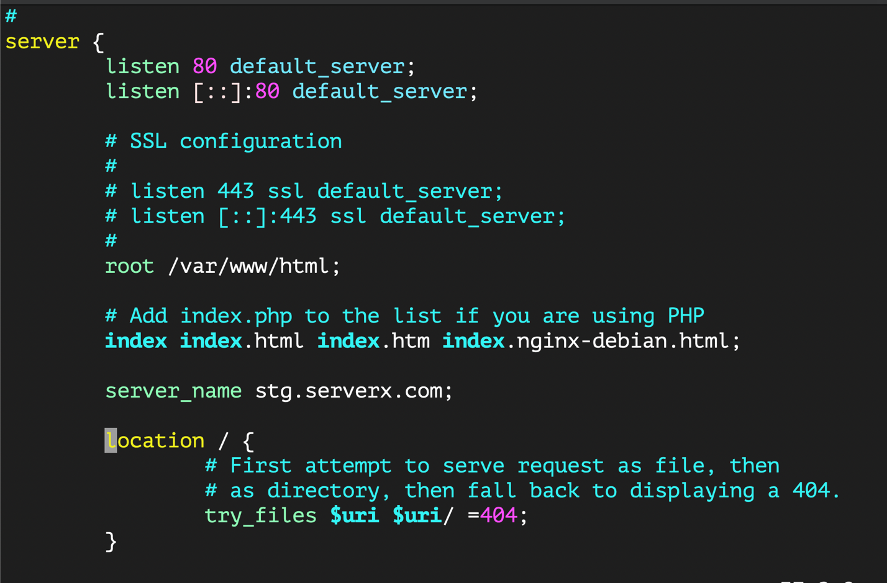

1. Test ngnix configuration

$ sudo nginx -t

1. Go to /var/www/html create file called index.html and edit it then restart nginx
2. $ sudo systemctl restart nginx

1. Create database

Create DataBase testing_db;

Show Databases;

CREATE USER 'test_user'@'%' IDENTIFIED WITH mysql_native_password BY 'Password';

GRANT ALL db_name.* to user@sql_server;

GRANT ALL on testing_db.* TO 'test_user'@'%';

CREATE TABLE testing_db.todo_list (

item_id INT AUTO_INCREMENT,

content VARCHAR(255),

PRIMARY KEY(item_id)

);

**INSERT INTO testing_db.todo_list (content) VALUES ("Create simple devops project");**

**INSERT INTO testing_db.todo_list (content) VALUES ("Visit my reletives");**

**INSERT INTO testing_db.todo_list (content) VALUES ("Go to GYM");**

**INSERT INTO testing_db.todo_list (content) VALUES ("Playing tennis");**

Then exit

1. Go to /var/www/html create file called todo_lists.php

<?php

$user = "example_user";

$password = "password";

$database = "example_database";

$table = "todo_list";

try {

$db = new PDO("mysql:host=localhost;dbname=$database", $user, $password);

echo "<h2>TODO</h2><ol>";

foreach($db->query("SELECT content FROM $table") as $row) {

echo "<li>" . $row['content'] . "</li>";

}

echo "</ol>";

} catch (PDOException $e) {

print "Error!: " . $e->getMessage() . "<br/>";

die();

}

